<https://handsonreact.com/docs/labs/ts/CreatingDataStructures>

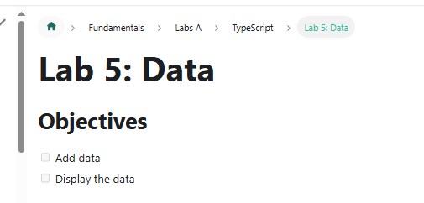

Move project to my GitHub as shown below:

* <https://github.com/CHDReactApps/create-new-react-keeptrack-app.git>

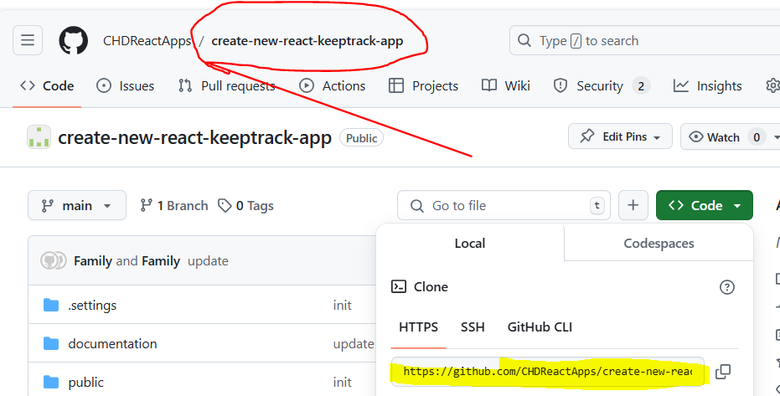

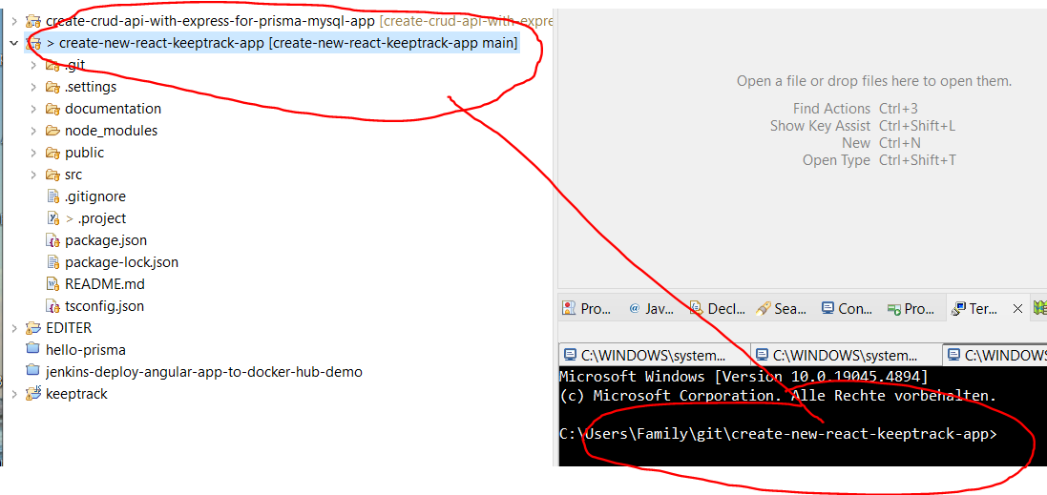

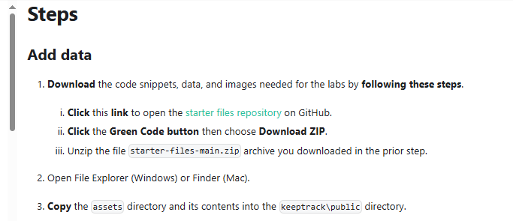

**Steps[​](https://handsonreact.com/docs/labs/ts/CreatingDataStructures" \l "steps" \o "Direct link to heading)**

**Add data[​](https://handsonreact.com/docs/labs/ts/CreatingDataStructures" \l "add-data" \o "Direct link to heading)**

1. **Download** the code snippets, data, and images needed for the labs by **following these steps**.
   1. **Click** this **link** to open the [starter files repository](https://github.com/craigmckeachie/react-starter-files) on GitHub.
   2. **Click** the **Green Code button** then choose **Download ZIP**.
   3. Unzip the file starter-files-main.zip archive you downloaded in the prior step.

* **Click** this **link** to open the [starter files repository](https://github.com/craigmckeachie/react-starter-files) on GitHub.

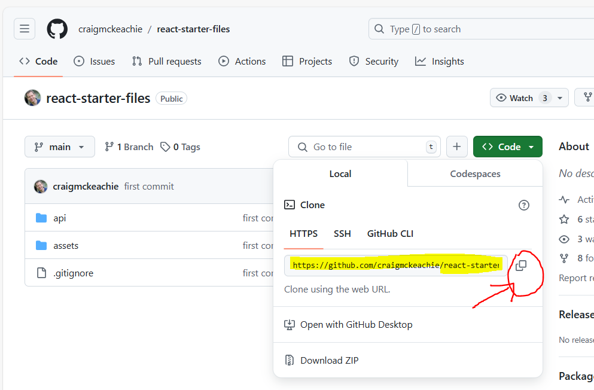

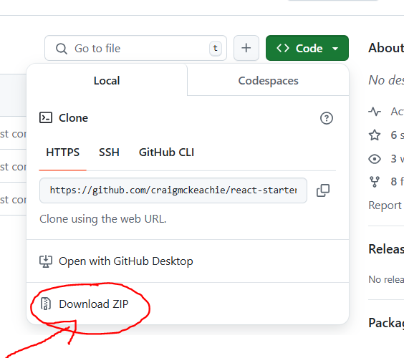

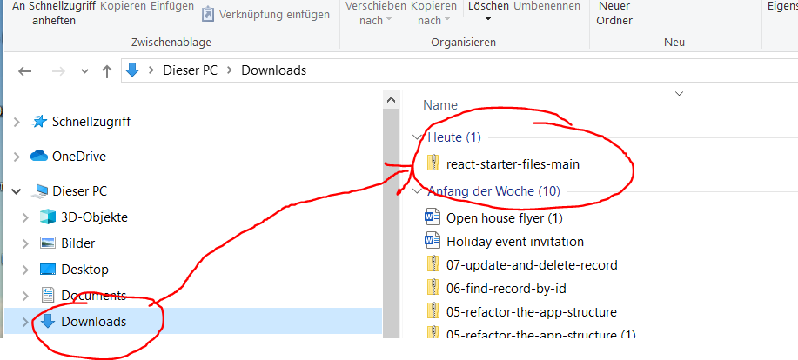



* **Copy** the assets directory and its contents into the keeptrack\public directory.

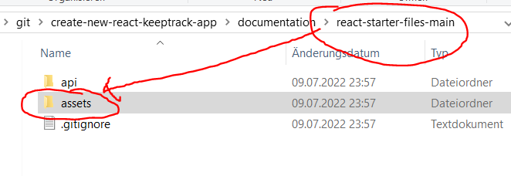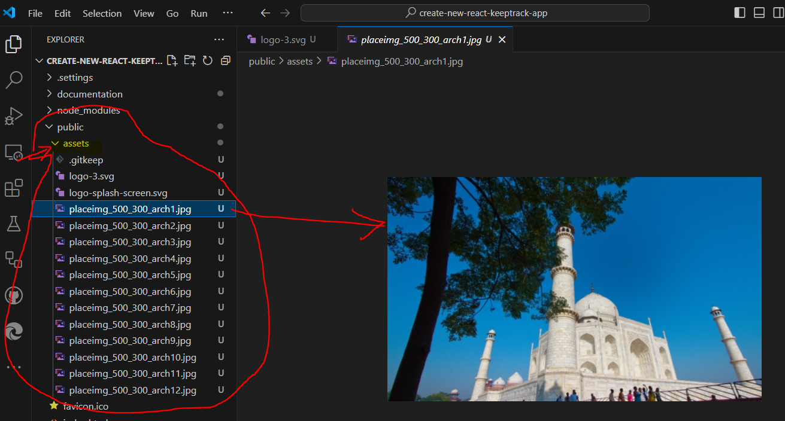

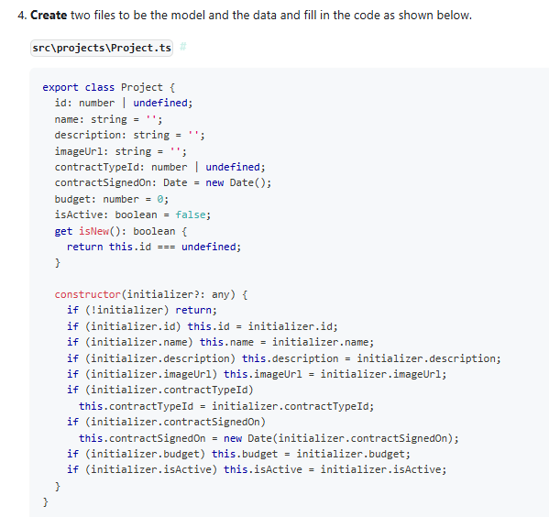

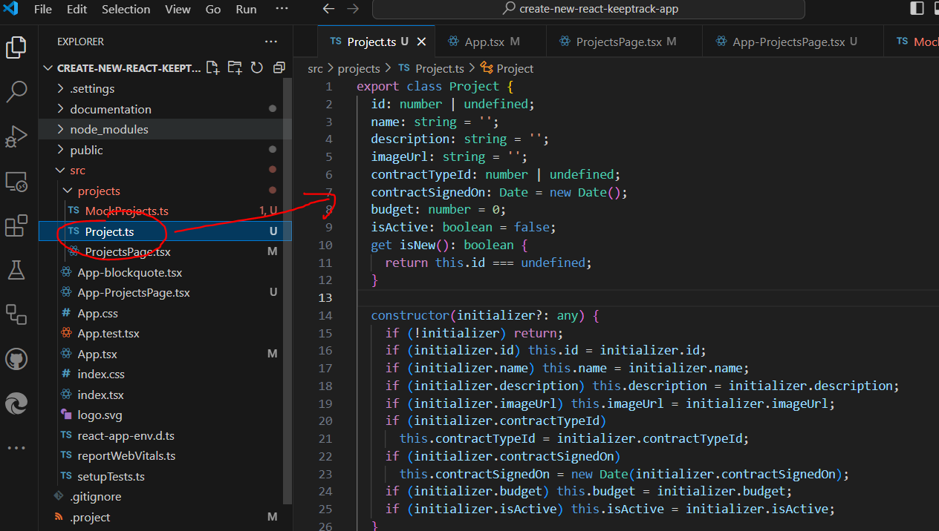

**src\projects\Project.ts[​](https://handsonreact.com/docs/labs/ts/CreatingDataStructures" \l "srcprojectsprojectts" \o "Direct link to heading)**

export class Project {  
 id: number | undefined;  
 name: string = '';  
 description: string = '';  
 imageUrl: string = '';  
 contractTypeId: number | undefined;  
 contractSignedOn: Date = new Date();  
 budget: number = 0;  
 isActive: boolean = false;  
 get isNew(): boolean {  
 return this.id === undefined;  
 }  
  
 constructor(initializer?: any) {  
 if (!initializer) return;  
 if (initializer.id) this.id = initializer.id;  
 if (initializer.name) this.name = initializer.name;  
 if (initializer.description) this.description = initializer.description;  
 if (initializer.imageUrl) this.imageUrl = initializer.imageUrl;  
 if (initializer.contractTypeId)  
 this.contractTypeId = initializer.contractTypeId;  
 if (initializer.contractSignedOn)  
 this.contractSignedOn = new Date(initializer.contractSignedOn);  
 if (initializer.budget) this.budget = initializer.budget;  
 if (initializer.isActive) this.isActive = initializer.isActive;  
 }  
}

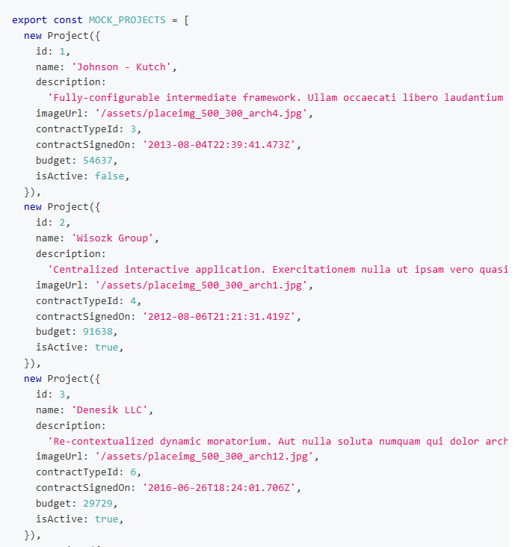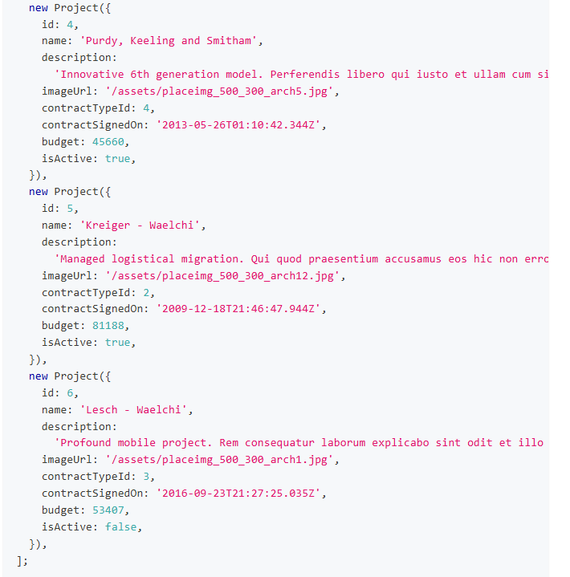

**src\projects\MockProjects.ts[​](https://handsonreact.com/docs/labs/ts/CreatingDataStructures" \l "srcprojectsmockprojectsts" \o "Direct link to heading)**

import { Project } from './Project';  
  
export const MOCK_PROJECTS = [  
 new Project({  
 id: 1,  
 name: 'Johnson - Kutch',  
 description:  
 'Fully-configurable intermediate framework. Ullam occaecati libero laudantium nihil voluptas omnis.',  
 imageUrl: '/assets/placeimg_500_300_arch4.jpg',  
 contractTypeId: 3,  
 contractSignedOn: '2013-08-04T22:39:41.473Z',  
 budget: 54637,  
 isActive: false,  
 }),  
 new Project({  
 id: 2,  
 name: 'Wisozk Group',  
 description:  
 'Centralized interactive application. Exercitationem nulla ut ipsam vero quasi enim quos doloribus voluptatibus.',  
 imageUrl: '/assets/placeimg_500_300_arch1.jpg',  
 contractTypeId: 4,  
 contractSignedOn: '2012-08-06T21:21:31.419Z',  
 budget: 91638,  
 isActive: true,  
 }),  
 new Project({  
 id: 3,  
 name: 'Denesik LLC',  
 description:  
 'Re-contextualized dynamic moratorium. Aut nulla soluta numquam qui dolor architecto et facere dolores.',  
 imageUrl: '/assets/placeimg_500_300_arch12.jpg',  
 contractTypeId: 6,  
 contractSignedOn: '2016-06-26T18:24:01.706Z',  
 budget: 29729,  
 isActive: true,  
 }),  
 new Project({  
 id: 4,  
 name: 'Purdy, Keeling and Smitham',  
 description:  
 'Innovative 6th generation model. Perferendis libero qui iusto et ullam cum sint molestias vel.',  
 imageUrl: '/assets/placeimg_500_300_arch5.jpg',  
 contractTypeId: 4,  
 contractSignedOn: '2013-05-26T01:10:42.344Z',  
 budget: 45660,  
 isActive: true,  
 }),  
 new Project({  
 id: 5,  
 name: 'Kreiger - Waelchi',  
 description:  
 'Managed logistical migration. Qui quod praesentium accusamus eos hic non error modi et.',  
 imageUrl: '/assets/placeimg_500_300_arch12.jpg',  
 contractTypeId: 2,  
 contractSignedOn: '2009-12-18T21:46:47.944Z',  
 budget: 81188,  
 isActive: true,  
 }),  
 new Project({  
 id: 6,  
 name: 'Lesch - Waelchi',  
 description:  
 'Profound mobile project. Rem consequatur laborum explicabo sint odit et illo voluptas expedita.',  
 imageUrl: '/assets/placeimg_500_300_arch1.jpg',  
 contractTypeId: 3,  
 contractSignedOn: '2016-09-23T21:27:25.035Z',  
 budget: 53407,  
 isActive: false,  
 }),  
];

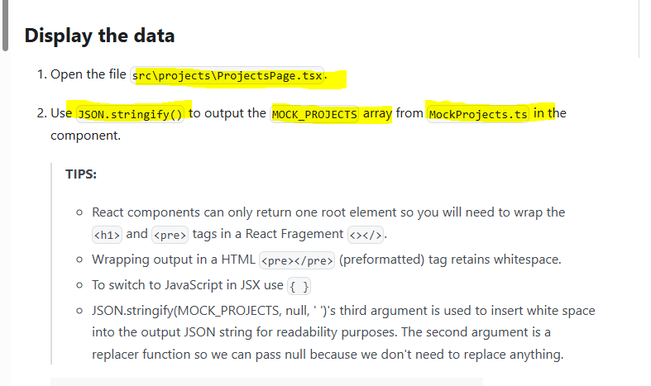

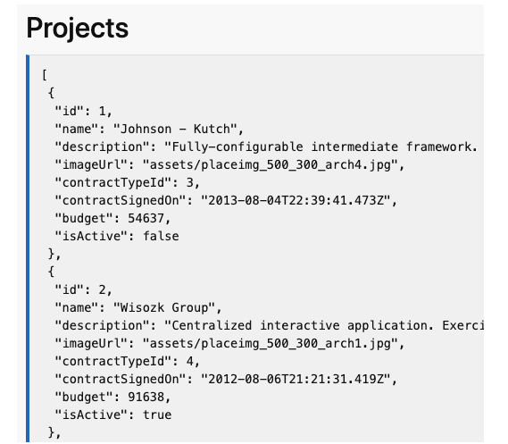

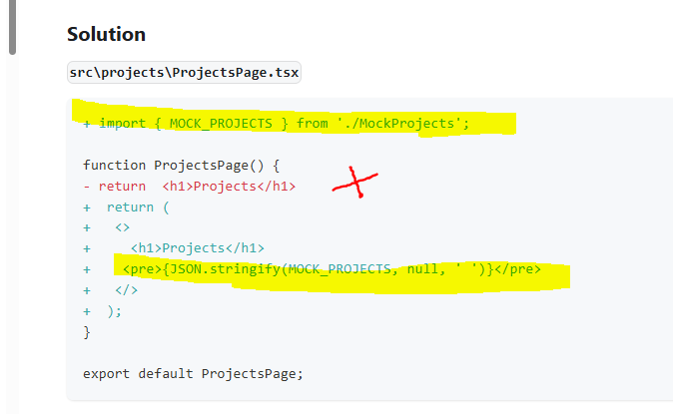

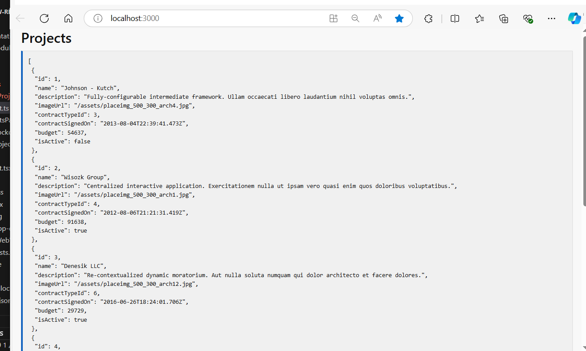

* <http://localhost:3000/>

Projects

{

"id": 1,

"name": "Johnson - Kutch",

"description": "Fully-configurable intermediate framework. Ullam occaecati libero laudantium nihil voluptas omnis.",

"imageUrl": "/assets/placeimg_500_300_arch4.jpg",

"contractTypeId": 3,

"contractSignedOn": "2013-08-04T22:39:41.473Z",

"budget": 54637,

"isActive": false

},

{

"id": 2,

"name": "Wisozk Group",

"description": "Centralized interactive application. Exercitationem nulla ut ipsam vero quasi enim quos doloribus voluptatibus.",

"imageUrl": "/assets/placeimg_500_300_arch1.jpg",

"contractTypeId": 4,

"contractSignedOn": "2012-08-06T21:21:31.419Z",

"budget": 91638,

"isActive": true

},

{

"id": 3,

"name": "Denesik LLC",

"description": "Re-contextualized dynamic moratorium. Aut nulla soluta numquam qui dolor architecto et facere dolores.",

"imageUrl": "/assets/placeimg_500_300_arch12.jpg",

"contractTypeId": 6,

"contractSignedOn": "2016-06-26T18:24:01.706Z",

"budget": 29729,

"isActive": true

},

{

"id": 4,

"name": "Purdy, Keeling and Smitham",

"description": "Innovative 6th generation model. Perferendis libero qui iusto et ullam cum sint molestias vel.",

"imageUrl": "/assets/placeimg_500_300_arch5.jpg",

"contractTypeId": 4,

"contractSignedOn": "2013-05-26T01:10:42.344Z",

"budget": 45660,

"isActive": true

},

{

"id": 5,

"name": "Kreiger - Waelchi",

"description": "Managed logistical migration. Qui quod praesentium accusamus eos hic non error modi et.",

"imageUrl": "/assets/placeimg_500_300_arch12.jpg",

"contractTypeId": 2,

"contractSignedOn": "2009-12-18T21:46:47.944Z",

"budget": 81188,

"isActive": true

},

{

"id": 6,

"name": "Lesch - Waelchi",

"description": "Profound mobile project. Rem consequatur laborum explicabo sint odit et illo voluptas expedita.",

"imageUrl": "/assets/placeimg_500_300_arch1.jpg",

"contractTypeId": 3,

"contractSignedOn": "2016-09-23T21:27:25.035Z",

"budget": 53407,

"isActive": false

}

]

